Research Procedure Doc for Value Investing Journey
This Doc is the exact procedure I go through every time I start researching companies.
Before coming up with this I used to spend hours researching companies on a preliminary basis that were terrible. After coming up with this procedure I can now evaluate five to 10 companies on a preliminary basis.
Not only will this list help save you a ton of time. But it will also help you find good companies faster.
If you consider different numbers to be more or less important feel free to change the doc in any way you want.
Step 1
Go through list of companies provided one by one. Use Morningstar to do preliminary analysis.
Step 2
Go to Morningstar.com and input the stock name or stock ticker into the box that says quote at the top of the page in the middle.
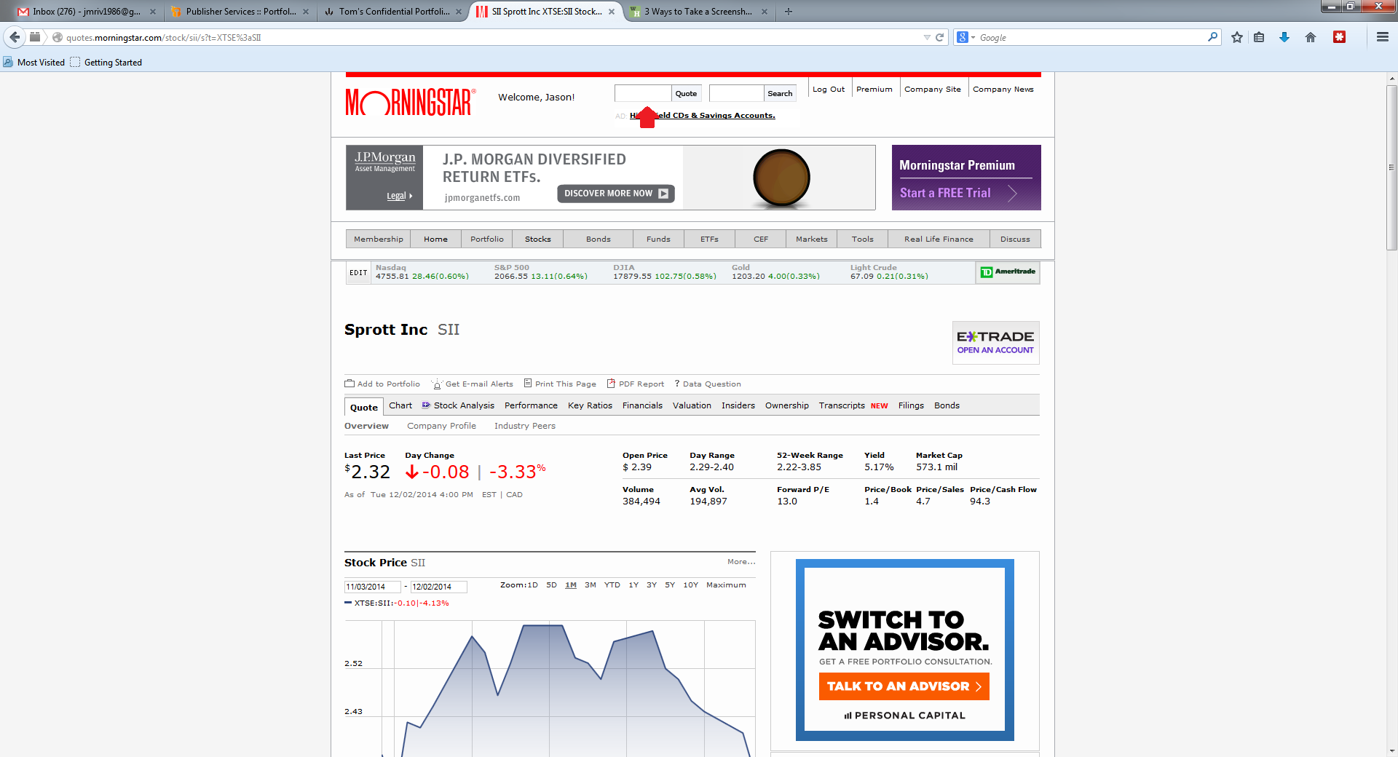
Step 3
Once you input the ticker name and get to the Quote page – which looks like the page above – you can start research.
Step 4
Open a new Word doc so that you can write down all the information that will be outlined below.
Step 5
From this page note the following: Dividend yield, price to book, industry price to book, PE, industry PE, market cap, current share price, % to 52 week low, if any special dividends have been paid recently, the number of analysts covering the stock, operating income, and free cash flow.
These can all be found at the top of the page like shown above or by scrolling down the page like shown below.
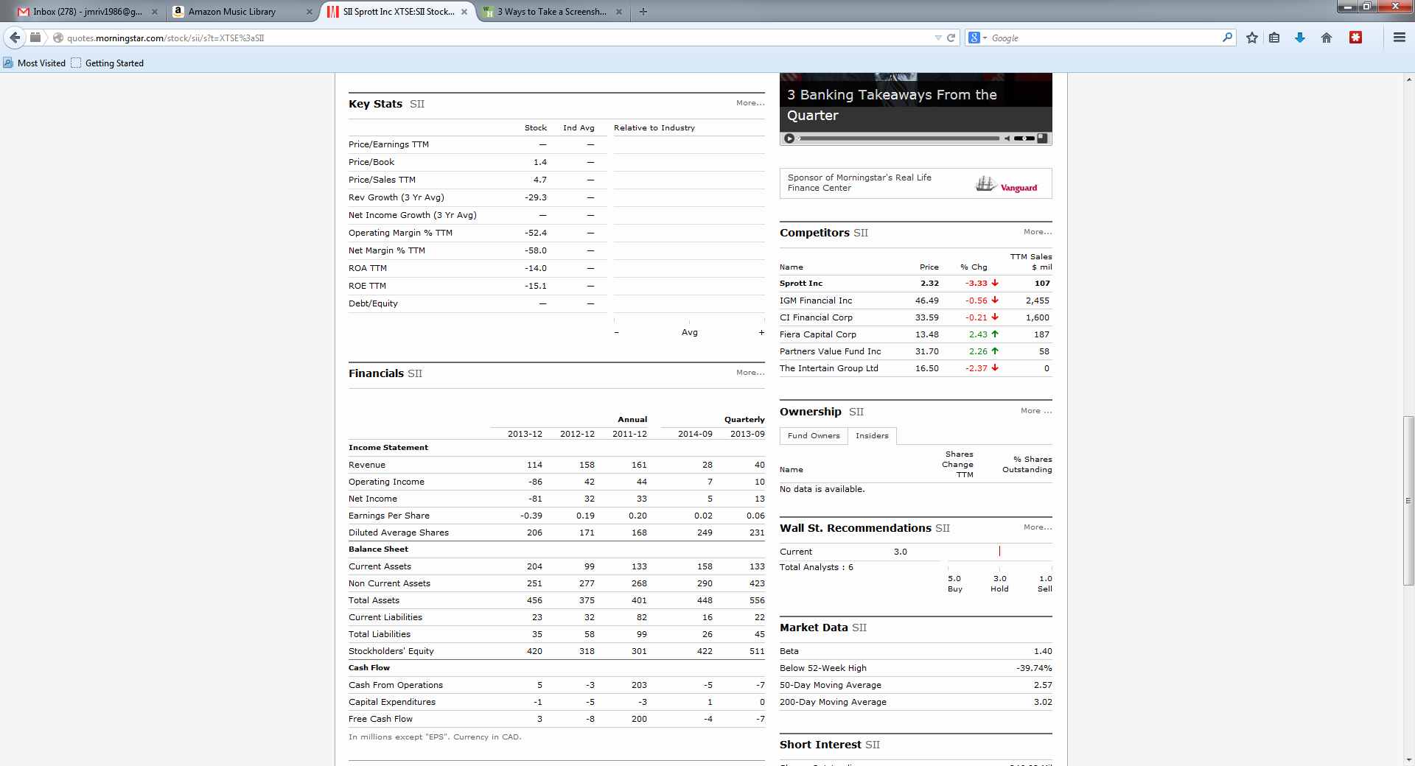
Step 6
Next go back to the top of the page and click on the Key Ratios Tab.
Step 7
The page will look like this.
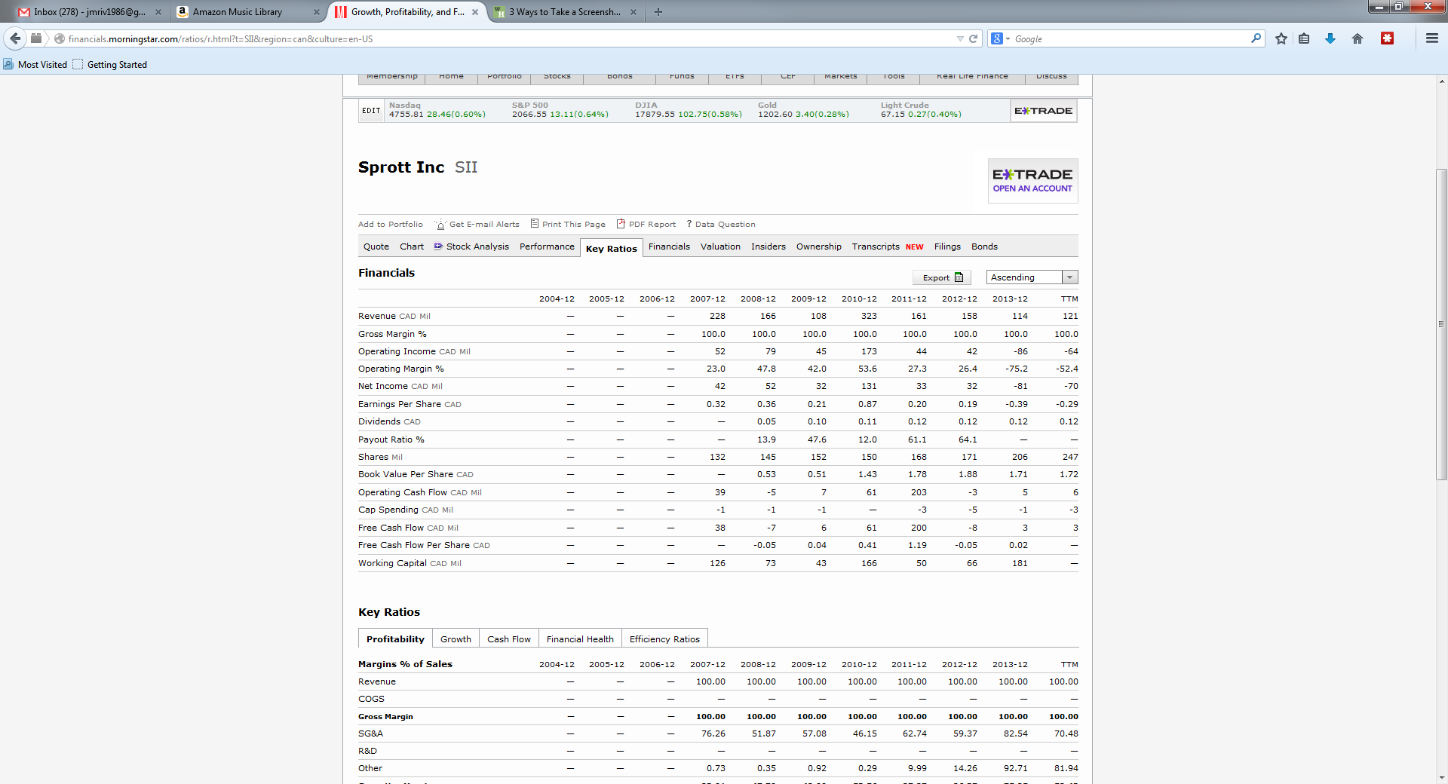
Once here make note of the company’s revenue over time. It’s operating margin % TTM and over the last five years. The number of shares it has TTM and over time. Book value per share TTM and over last five years. Book value per share percentage gain/loss over last 5 years. ROIC TTM and over time. ROE TTM and over time.
ROIC and ROE can be found by scrolling down the page.
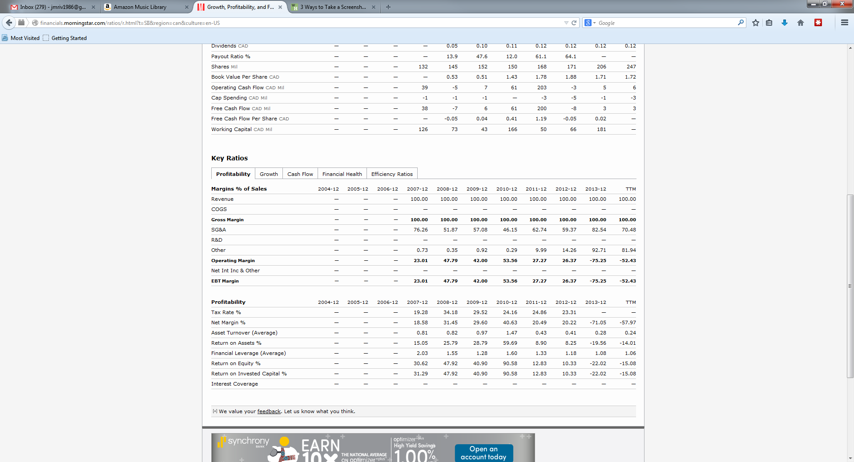
Step 8
After this click on the Cash Flow tab at the bottom of the page.
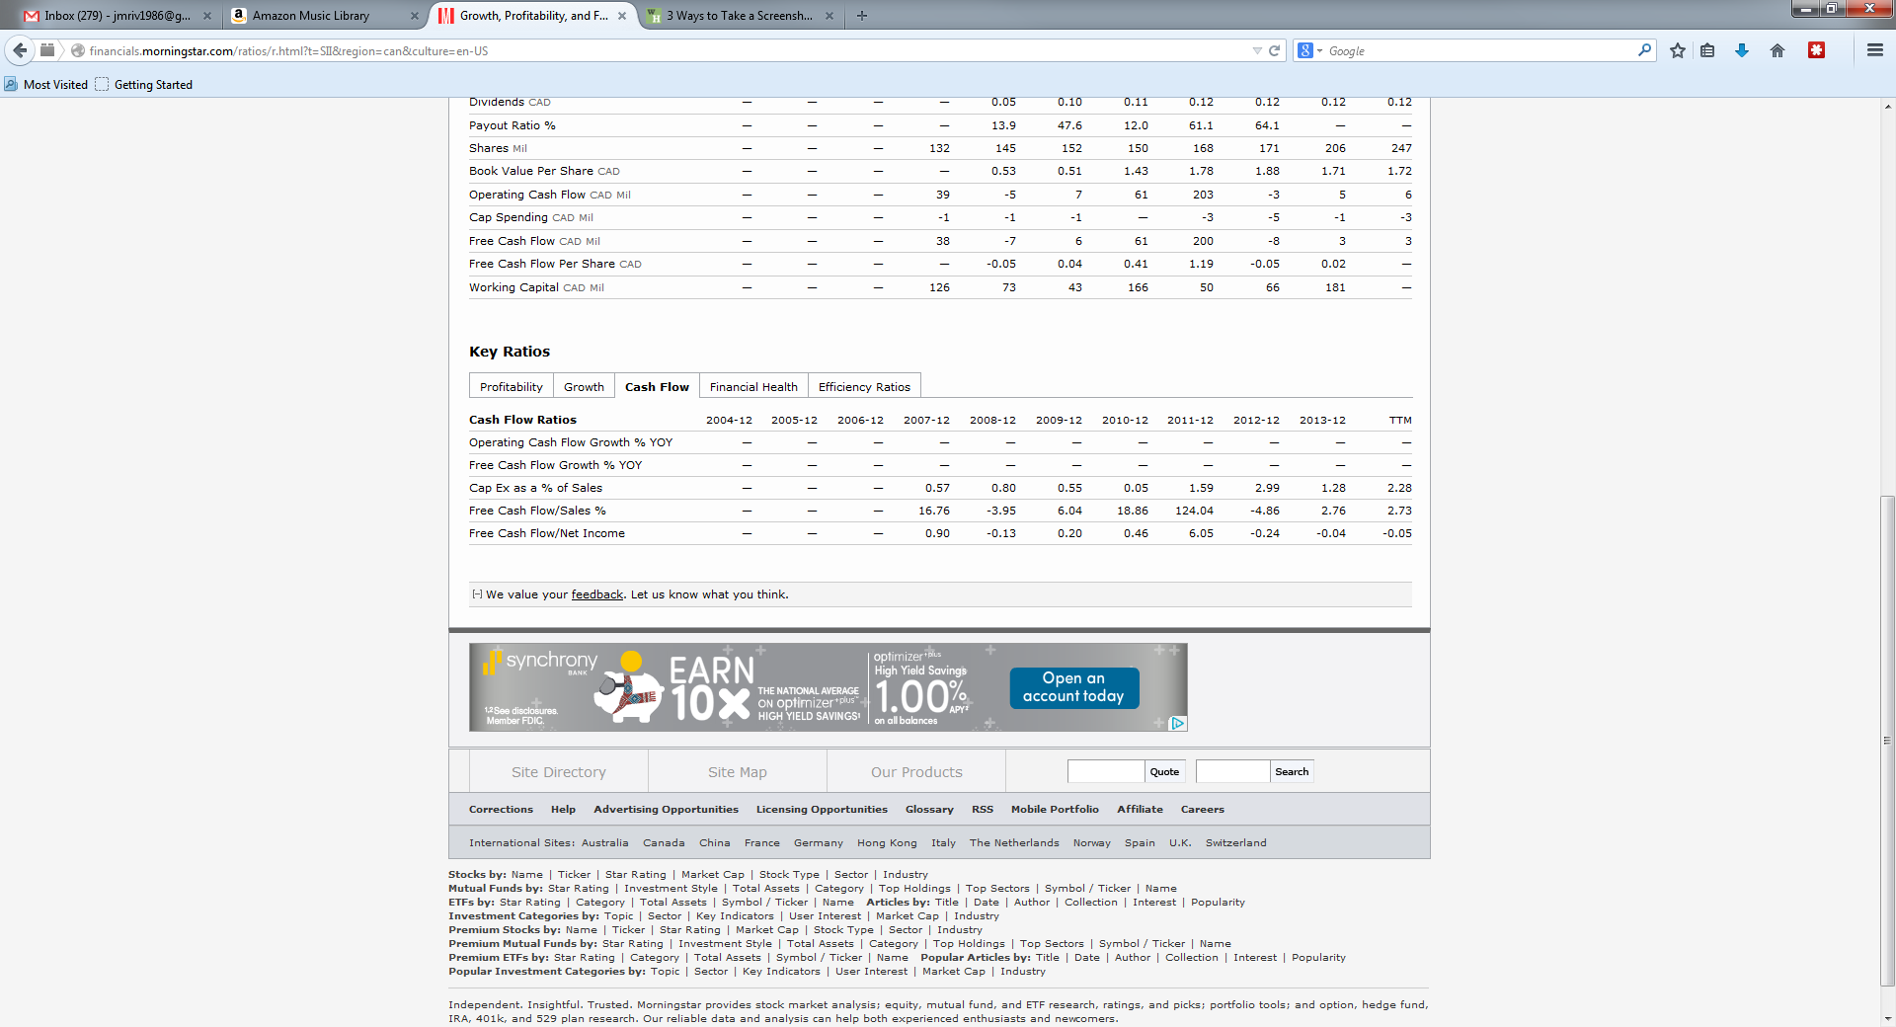
Once here make note of the free cash flow/Sales % TTM and over time.
Step 9
Click on the Financial Health Tab.
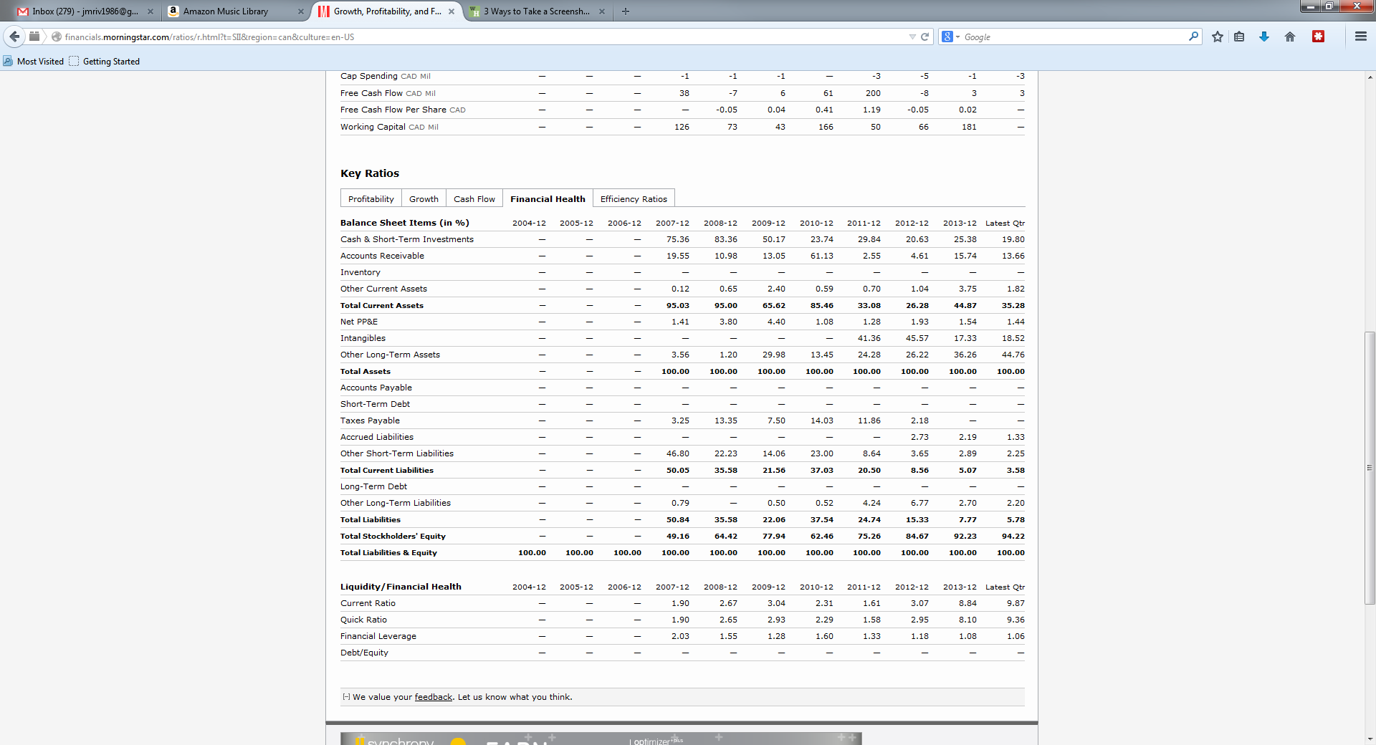
Once here make note of the Cash and short term investments % for the latest quarter and get and average for the last 5 years. Same for accounts receivable, inventory, short term debt, and long term debt.
Make special note if something looks off here. If a company has a lot of cash, a lot of debt, rising inventory levels.
Step 10
Click on the Efficiency Ratios Tab.
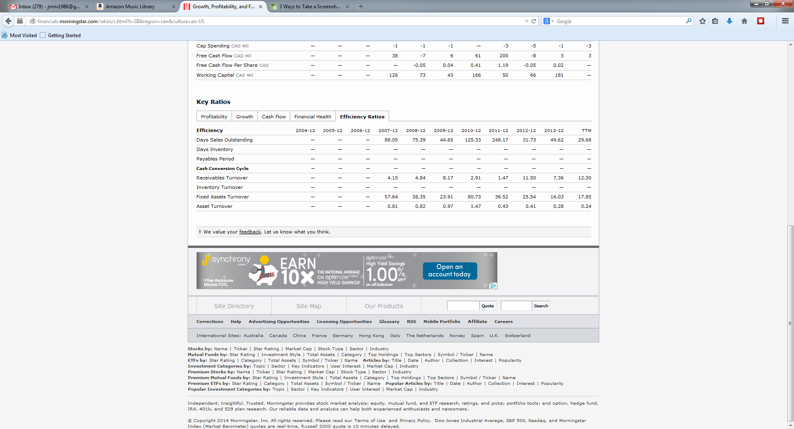
Once here make note of the Cash Conversion Cycle number TTM and get a 5 year average.
Step 11
Scroll back up to the top of the page and click on the financials tab. Open up a tab in your browser for each of the following: Income Statement, Balance Sheet, and Cash Flow Statement.
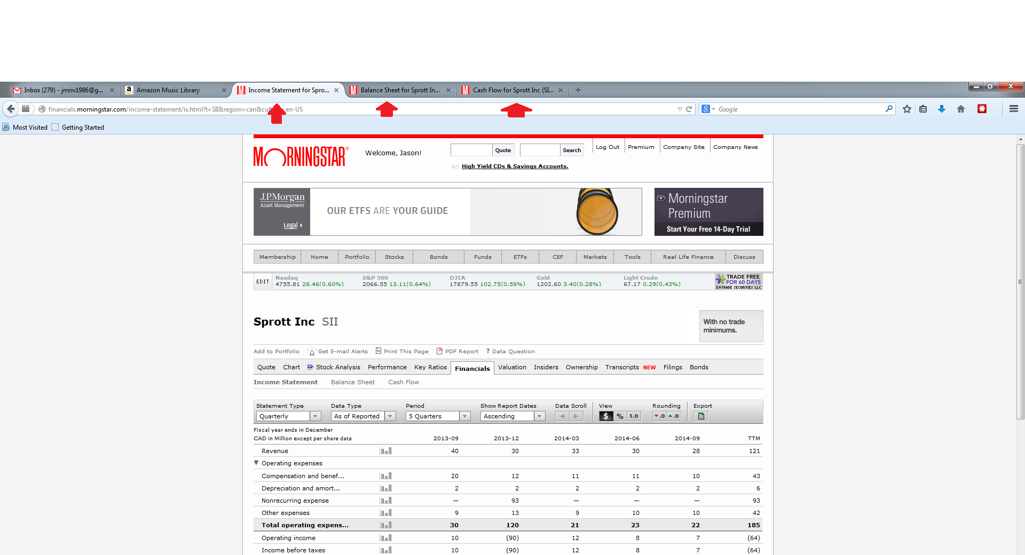
Step 12
At this point your notes should look something like this.
General Mills Notes
- $31.2 billion market cap.
- 3.1% dividend yield.
- TTM operating margin is 15.6%.
- 5 year average OM is 16.8%.
- 10 year average OM is 16.7%.
- They have reduced share count from 818 million in 2005 to 638 million in the TTM period. Or a reduction of 23% since then.
- They have grown book value per share from $7.68 a share in 2005 to $10.27 a share TTM. Or a gain of 25% since then.
- Morningstar ROIC TTM is 11.2%.
- 5 year average Morningstar ROIC is 14.1%
- 10 year average Morningstar ROIC is 13.1%.
- TTM ROE is 26.2%.
- 5 year average ROE is 28%.
- 10 year average ROE is 24.8%.
- TTM FCF/sales is 10.1%.
- 5 year average FCF/sales is 10%.
- 10 year average FCF/sales is 10.2%
- Its CCC has jumped from 28 days in 2005 to 43 days TTM. A gain of 35%.
Step 13
Calculate the companies enterprise value (EV)
You do this by taking the companies market cap from the front quote page or your notes. Going to the balance sheet page. Subtract TTM cash, cash equivalents, and short term investments. Then Add TTM Short term and long term debt.
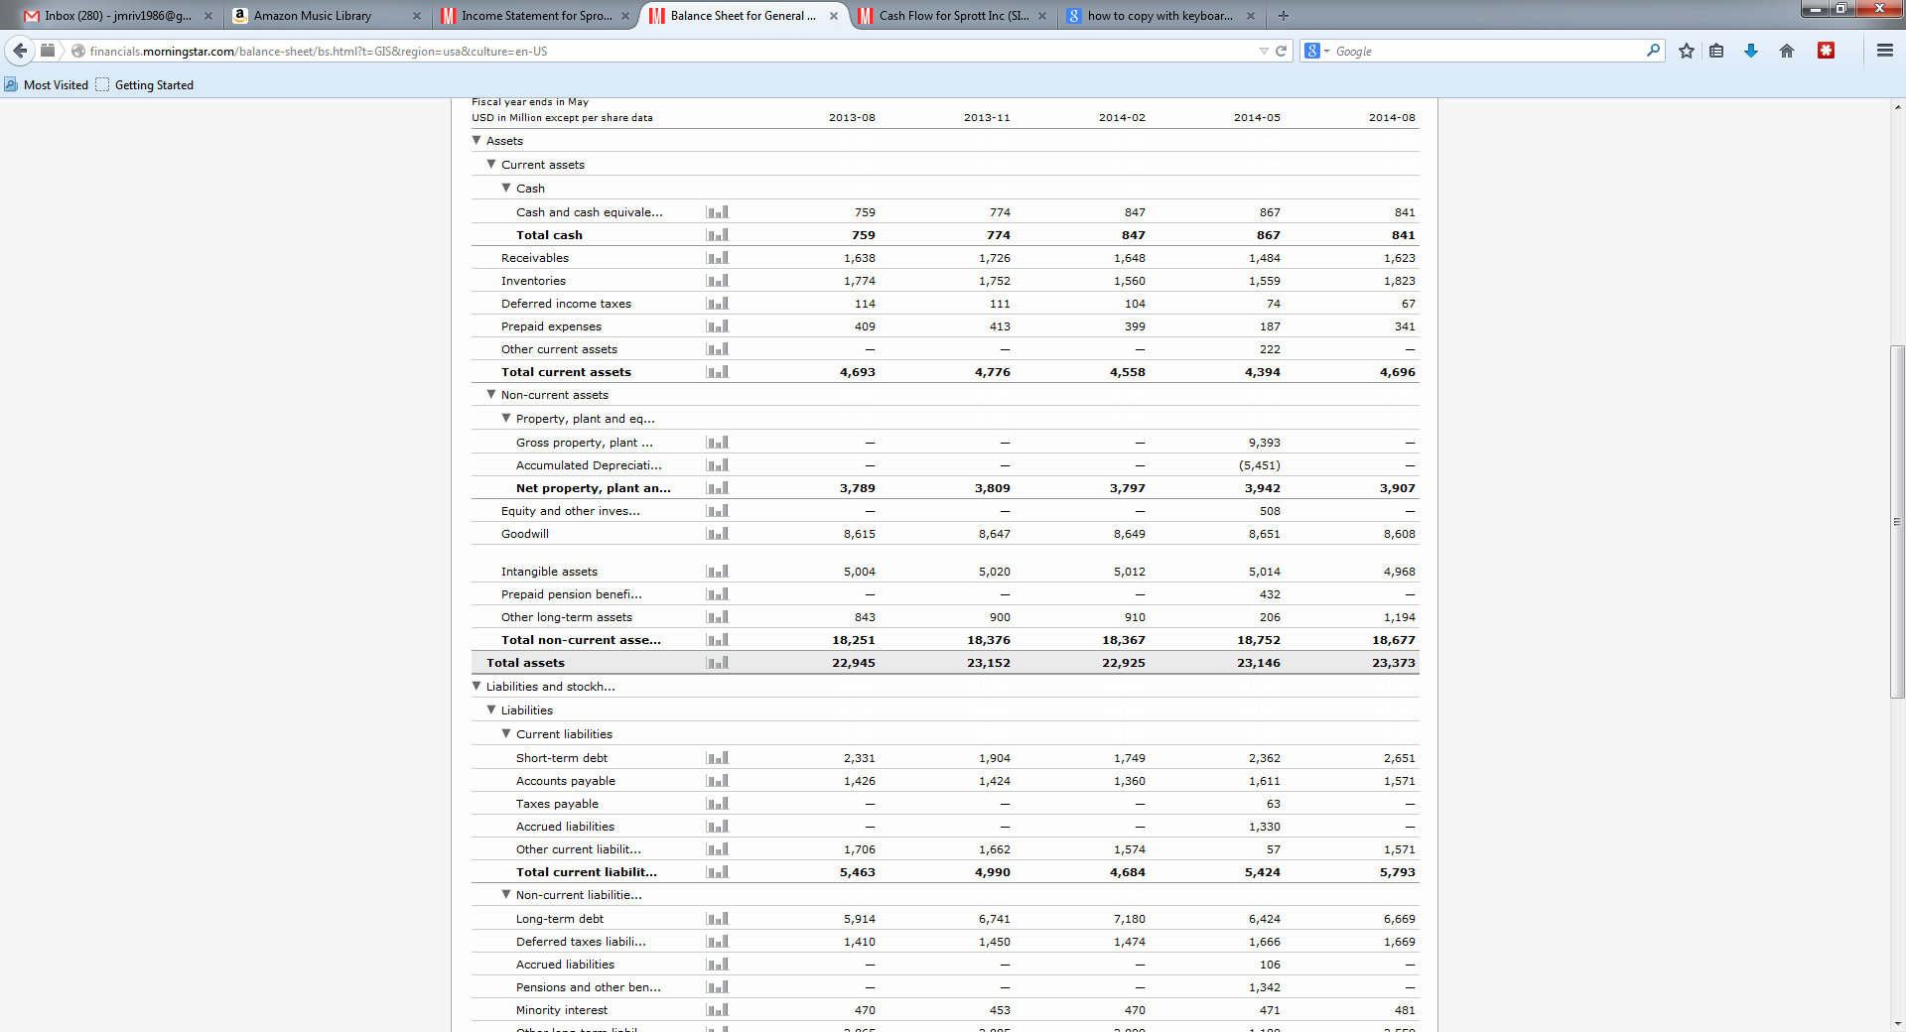
Sprott didn’t have any debt so I substituted them for General Mills above to show where to look.
Step 14
Once you have the companies EV go to the income page and find the companies TTM operating margin. Also called EBIT below.
Step 15
Now go to the cash flow statement to and get a company’s TTM Free Cash Flow. Also called FCF Below.
Step 16
Now that you have all three of those numbers you can do some relative valuation calculations.
Divide EV/EBIT and write that number down. I prefer this number to be 8 and below but below 10 will work here.
Divide EV/FCF and write that number down. Again I prefer this number to be 8 or below. 15 and below will work for this number.
Step 17
Now reverse the above two calculation to the company’s earnings yield at current prices.
EBIT/EV and FCF/EV respectively.
Calculate those numbers and write them down.
The higher this number is the better but I look for 10% and above.
Step 18
You Word Doc should now look like this:
- $31.2 billion market cap.
- 3.1% dividend yield.
- TTM operating margin is 15.6%.
- 5 year average OM is 16.8%.
- 10 year average OM is 16.7%.
- They have reduced share count from 818 million in 2005 to 638 million in the TTM period. Or a reduction of 23% since then.
- They have grown book value per share from $7.68 a share in 2005 to $10.27 a share TTM. Or a gain of 25% since then.
- Morningstar ROIC TTM is 11.2%.
- 5 year average Morningstar ROIC is 14.1%
- 10 year average Morningstar ROIC is 13.1%.
- TTM ROE is 26.2%.
- 5 year average ROE is 28%.
- 10 year average ROE is 24.8%.
- TTM FCF/sales is 10.1%.
- 5 year average FCF/sales is 10%.
- 10 year average FCF/sales is 10.2%
- Its CCC has jumped from 28 days in 2005 to 43 days TTM. A gain of 35%.
- EV/EBIT is 14.3.
- EV/FCF is 22.
- EBIT/EV (earnings yield) – XYZ%
- FCF/EV (earnings yield) – XYZ%
Step 18
Feel free to add notes of interest at to the end of this doc. Things like if the company is paying a special dividend. If it’s selling at a P/B less than 1. Has an EV/EBIT or EV/FCF below 8. If the company has NOL’s. The companies debt levels compared to cash and cash production. Eetc.
Of note is that some of this information you might not be able to find on Morningstar. This may happen with some foreign or smaller companies. In this case you will need to go to the company’s website… Download its financial reports from there… And then go through the financial reports to find this information.
Step 19
Done.
By now you should know on a preliminiary basis whether you want to continue researching the company or not based on the types of criteria that are most important to you.

