Armanino Foods (AMNF) Financial Info
General Info
- Business and Basis of Presentation - The consolidated financial statements include the accounts of Armanino Foods of Distinction, Inc. (the “Company”), which engages in the production and marketing of upscale and innovative food products, including primarily frozen pesto sauces, frozen pasta products, cooked and frozen meat and poultry products, and its wholly-owned dormant subsidiary AFDI, Inc. which was incorporated in May 1995.
- The Company's line of frozen products presently includes pesto sauces, stuffed pastas and pasta sheets, as well as value-added specialty Italian pastas, and cooked meat products.
- These products are marketed through a network of food brokers and sold to retail and foodservice distributors, club-type stores and industrial accounts. The products and these labels are identified as such in each product's category described below.
- The Company presently markets a line of pesto sauces which are available in several varieties: Basil, Classic Ligurian Basil, Cilantro, Dried Tomato-Garlic, Roasted Red Bell Pepper, Artichoke, and Chipotle, Roasted Garlic, as well as a white sauce and a mushroom sauce, all of which are packaged under the Armanino label. The Basil pesto sauce is available to the Company's retail, foodservice and industrial customers, and the Roasted Garlic, Dried Tomato Garlic, Roasted Red Bell Pepper, Cilantro, Classic Ligurian Basil, Artichoke and Chipotle pesto sauces and the white and mushroom sauces are available to foodservice industrial customers, only. In addition, the Company makes organic Basil Pestos available to the Company’s foodservice customers.
- The Company markets several lines of frozen pastas, namely stuffed pastas and pasta sheets, cooked and uncooked. The Company's line of frozen stuffed pastas, both cooked and uncooked, includes meat, butternut squash, cheese ravioli and jumbo cheese, jumbo mushroom ravioli; jumbo cheese/spinach green dough ravioli; cheese raviolini; meat filled, tricolor cheese and cheese tortellini; and tri-color cheese and cheese capelletti, manicotti and stuffed shells. The meat and cheese ravioli and tri-color and cheese tortellini are available to the Company's retail and foodservice customers. The aforementioned stuffed pasta products, as well as potato gnocchi are available to the Company's foodservice customers only. All of these products are sold under the Armanino brand label.
- The Company also sells cooked beef and turkey meatballs, and cheese shakers under the Armanino label. These products are only available to retail customers.
- The Company faces substantial competition in its business. Because many of the Company's products are sold frozen, they have a relatively shorter shelf life and are more expensive than many competing dried products and products packed in cans or jars. Although these types of competing products are marketed by some companies which have significantly greater financial and other resources than those of the Company, including advertising budgets, the Company markets its products on the basis of quality and natural ingredients rather than price.
- With respect to other frozen food manufacturers, the Company believes that its products are highly competitive with other frozen products in pricing and quality. However, the Company faces stiff competition in the area of ongoing promotional support, and the Company often finds it difficult to convince new accounts to change their established suppliers. The Company may also face competition from future entrants into theindustry.

Financial Info
- 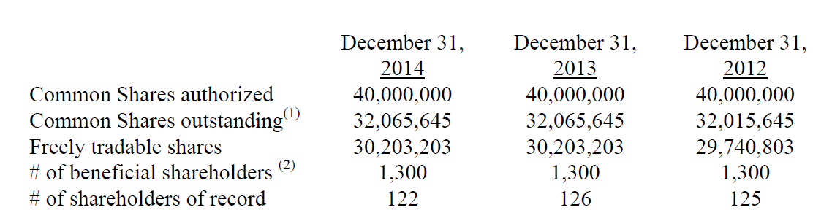
- Restrictions on the transfer of securities:1,862,442 shares of common stock are restricted as of 12/31/14; 1,862,442 shares of common stock are restricted as of 12/31/13; and, 2,274,842 shares as of 12/31/12.
- ISSUER’S FACILITIES - The Company leases approximately 24,375 square feet of office, production and warehouse space located at 30588 San Antonio Street, Hayward, California, 94544. The Company also leases approximately 7,408 square feet of additional office and warehouse space located at 30641 San Antonio Street, Hayward, California, 94544. Except for a Co2 tank which it leases, the Company owned all of its manufacturing equipment as of December 31, 2014.
- Advertising Cost - Cost incurred in connection with advertising of the Company’s products are expensed as incurred. Such costs amounted to $3,255, $1,805 and $2,330, for the years ended December 31, 2014, 2013 and 2012, respectively.
- During the years ended December 31, 2014, 2013 and 2012, the Company paid accounting fees of $9,245, $8,395 and $9,905, respectively to a company controlled by a director/shareholder. Services provided by this accounting firm are in the area of tax preparation and related services, management and business consulting.
- The Company’s inventory is held as collateral on the Company’s lines of credit.
- The Company’s property and equipment is held as collateral on the line of credits.
- 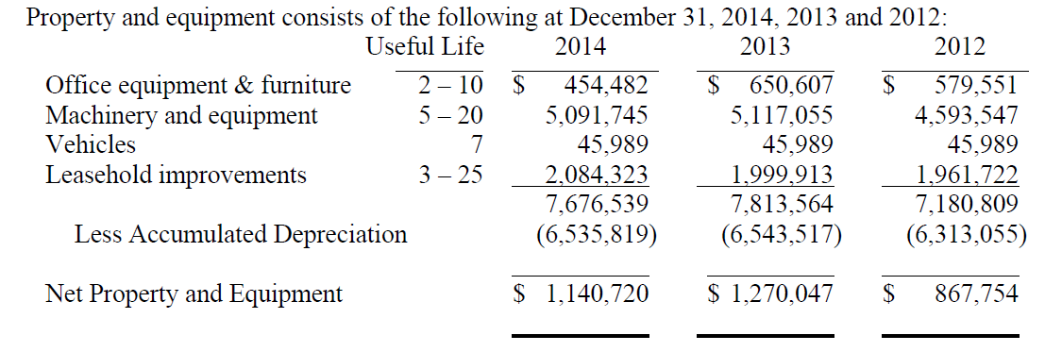
- 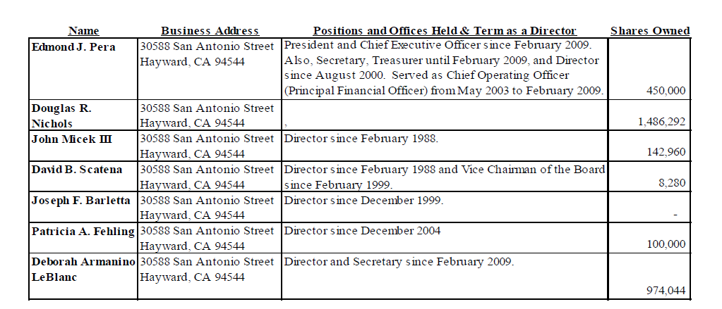
- 2014 full year numbers below
- 2015 Q1 numbers below
- 2014 full year numbers below
- 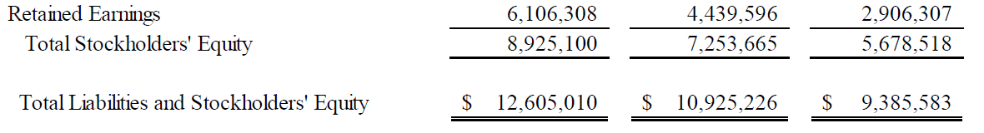
- 2015 Q1 numbers below
- 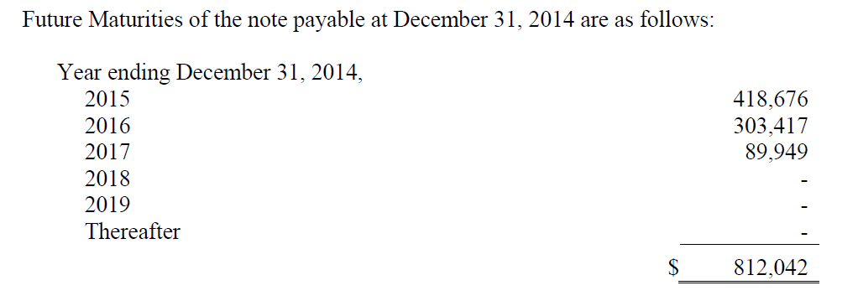
- 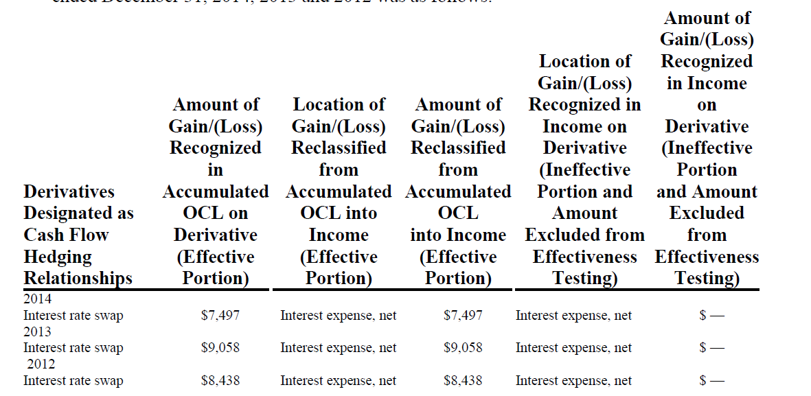
- Operating Leases -
- Common Stock Issuances – During 2013, the Company issued 50,000, shares of stock at $0.723 per share, upon exercise of stock options under the 2002 stock option plan.
- Dividends - During the years ended 2014, 2013 and 2012 the Company paid total dividends of $2,116,333, $1,282,024 and $2,322,512, respectively, none of which were considered a liquidating dividend.
- Treasury Stock - The Board of Directors has authorized the Company to repurchase up to $2,500,000 of the Company’s Common Stock at market prices. The amount and timing of the shares to be repurchased are at the discretion of management. During the years ended December 31, 2014, 2013 2012 and 2011, 0, 0, 631,736 and 2,425,799 common shares, at $0.70 to $0.94 per share at an aggregate cost of $2,394,294, were repurchased under this program. At December 31, 2014, the Company is authorized to repurchase an additional $105,706 worth of the Company’s common stock.
- The Company had two distributor customers who accounted for 55%, and 29% in 2014 of outstanding receivables at December 31, 2014. The Company had two distributor customers who accounted for 62% and 15% of outstanding receivables at December 31, 2013, and 62%, and 15%, at December 31, 2012.
- During the years ended December 31, 2014, 2013 and 2012, 54%, 54% and 50% of the Company’s total gross sales were handled by a non-exclusive national distributor.
- During the years ended December 31, 2014, 2013 and 2012 sales to the Company’s distributor in Asia amounted to 13%, 11% and 14%, of the Company’s total gross sales.
- 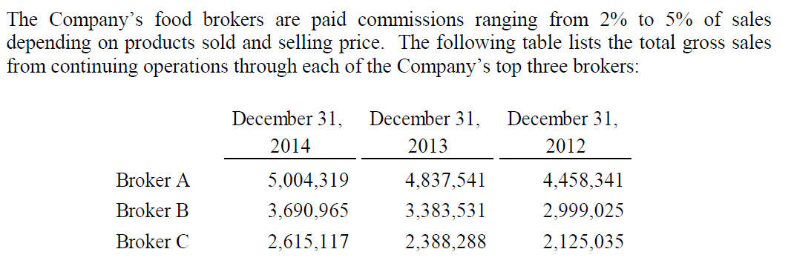
- As of December 31, 2014 the Company has acquired a total of 3,102,135 shares of its common stock at an aggregate purchase price of $2,394,294. The total number of shares repurchased represents approximately 9% of the Company’s common shares outstanding before the stock repurchases. The Company funded its stock repurchase program mainly through a $2,000,000 line of credit which it entered into with a financial institution back in September 2010, with the remaining balance being funded through cash reserves.
- 