Steiner Leisure (STNR) Notes from recent quarterly repot and two most recent annual reports. Notes done on 9/28/15
MY POINTS OF EMPHASIS AND NOTES ARE HIGHLIGHTED.
ALL NOTES FROM HERE UNTIL FURTHER NOTICE ARE FROM THE 2014 10K
Steiner Leisure Limited ("Steiner Leisure," the "Company," "we," "us" and "our" refer to Steiner Leisure Limited and its subsidiaries) is a worldwide provider and innovator in the fields of beauty, wellness and education. Steiner Leisure was incorporated in the Bahamas as a Bahamian international business company in 1995. In our facilities on cruise ships, at land-based spas, including at resorts and urban hotels (referenced collectively below as "hotels"), luxury Elemis® day spas, Bliss® premium urban day spas and at our Ideal Image laser hair removal centers ("Ideal Image centers"), we strive to create a relaxing and therapeutic environment where guests can receive beauty and body treatments of the highest quality. Our services include traditional and alternative massage, body and skin treatment options, fitness, acupuncture, medi-spa treatments and laser hair removal. We also develop and market premium quality beauty products, which are sold at our facilities, through e-commerce and through third party retail outlets and other channels, and operate post-secondary schools offering massage therapy and related courses.

The cruise ships and third party land-based venues we serve include those of Caesars Entertainment, Carnival Cruise Lines, Costa Cruises, Crystal Cruises, Cunard Cruise Line, Hilton Hotels, Holland America Line, Ibero Cruises, Kerzner International, Marriott Hotels, Nikko Hotels, Norwegian Cruise Lines, Planet Hollywood, P&O Cruises, Princess Cruises, Pullmantur Cruises, Royal Caribbean Cruises, Seabourn Cruise Line, Silversea Cruises, Sofitel Luxury Hotels, St. Regis Hotels and Resorts, W Hotels and Resorts, Westin Hotels and Resorts and Windstar Cruises. As of February 1, 2014, we served 156 cruise ships representing 18 cruise lines, and operated 52 resort spas, 11 urban hotel spas, five day spas and 109 Ideal Image centers.

We also operate 12 post-secondary schools (comprised of a total of 32 campuses) located in Arizona, Colorado, Connecticut, Florida, Illinois, Maryland, Massachusetts, Nevada, New Jersey, Pennsylvania, Texas, Utah, Virginia and Washington. As described in more detail below, legislation and regulations have placed significant restrictions on the operation of post-secondary schools, such as ours, that are dependent to a major extent on the ability of students and prospective students to obtain loans under Title IV of the Higher Education Act of 1965 (the "HEA"), which is administered by the U.S. Department of Education (the "DOE").

We provide our shipboard services in treatment and fitness facilities located on cruise ships. On most newer ships, our services are provided in enhanced, large spa facilities. Most of these facilities are in large fitness and treatment areas, generally located in a single passenger activity area. As of February 1, 2014, 118 of the 156 ships we served had large spa facilities. Ships with large spa facilities provided us with average weekly revenues of $61,089 in 2013 and $62,471 in 2012, as compared to average weekly revenues of $18,218 in 2013 and $18,384 in 2012 for the other ships we served. Our
services include massages, facials, microdermabrasion, waxing, aromatherapy treatments, seaweed wraps, aerobic exercise, yoga, Pilates, hair styling, manicures, pedicures and teeth whitening, as well as a variety of other specialized beauty and body treatments and services, acupuncture and, on many ships we serve, medi-spa services such as BOTOX® Cosmetic, Dysport®, Restylane® and Perlane®. Our range of services is designed to capitalize on the significant consumer interest in health awareness, personal care and fitness.

We provide spa services (other than medi-spa services) similar to those we provide on cruise ships at 63 hotels located in the United States, the Caribbean, Asia, the Pacific, and other locations. These spas are operated primarily under the Mandara® and Bliss brands. Additional spas under these brands and the Remède brand are operated by third parties under license from us. We also operate Elemis luxury day spas in each of Coral Gables, Florida and London, England, as well as Bliss premium urban day spas in New York City (two spas) and London.

We develop and sell a variety of high quality beauty products under our Elemis, La Thérapie™, Bliss, BlissLabs™, Remède, Laboratoire Remède, Mandara Spa® and Mandara brands, and supplements under our Jou® brand. Our products are produced for us by several suppliers, including premier United States and European manufacturers.
We also sell products of third parties, both under our packaging and labeling and under those of third parties. The products we sell include beauty preparations such as lotions aimed at reducing the appearance of aging on skin, aromatherapy oils, cleansers and creams and other facial and skin care preparations, hair care products, moisturizers and lotions, nail care products, footwear and shapewear, including, among others, a variety of products under the Steiner® and Mandara names. We sell our products through, among other channels, e-commerce, catalogs, on board the ships we serve, at our landbased spas, through department stores and third party retail outlets and distributors, as well as through salons, mail order and our websites, including
www.timetospa.com, www.timetospa.co.uk, www.blissworld.com, www.blisslondon.co.uk and www.bodyworkmall.com.

The passenger cruise industry has evolved from a trans-ocean carrier service into a vacation alternative to land-based venues and sightseeing destinations. The cruise market is comprised of luxury, premium and mass market segments which appeal to a broad range of passenger demographics, tastes and budgets. We serve ships in all of these segments.

According to Cruise Lines International Association, a trade association ("CLIA"), passenger volume on cruises marketed primarily to North American consumers ("North American Cruises") grew from approximately 12.6 million in 2007 to a CLIA-estimated 17.6 million in 2013, including an estimated increase of approximately 400,000 North American passengers in 2013 compared to 2012. The increase from 2012 to 2013 may continue to reflect passengers traveling due to discounts and other promotions offered by certain cruise lines. Passengers who are cruising solely due to discounted fares may reflect their cost consciousness by not spending on discretionary items, such as our services and products. In the event of a recurrence of the economic slowdown experienced worldwide in recent years, declines in passenger volume on cruises, including North American Cruises, could resume, which would adversely affect our business. As of February 1, 2014, 92 of the 156 ships we served offered North American Cruises.

As of February 1, 2014, we provided our services and products to 18 cruise lines representing a total of 156 ships, including almost all of the major cruise lines offering North American Cruises. We provide our services under the Mandara and The Greenhouse® brands, as well as under the proprietary brands of several cruise lines.

The numbers of ships served as of February 1, 2014 under cruise line agreements with the respective cruise lines (including ships temporarily out of service for routine dry dock maintenance) are listed below:

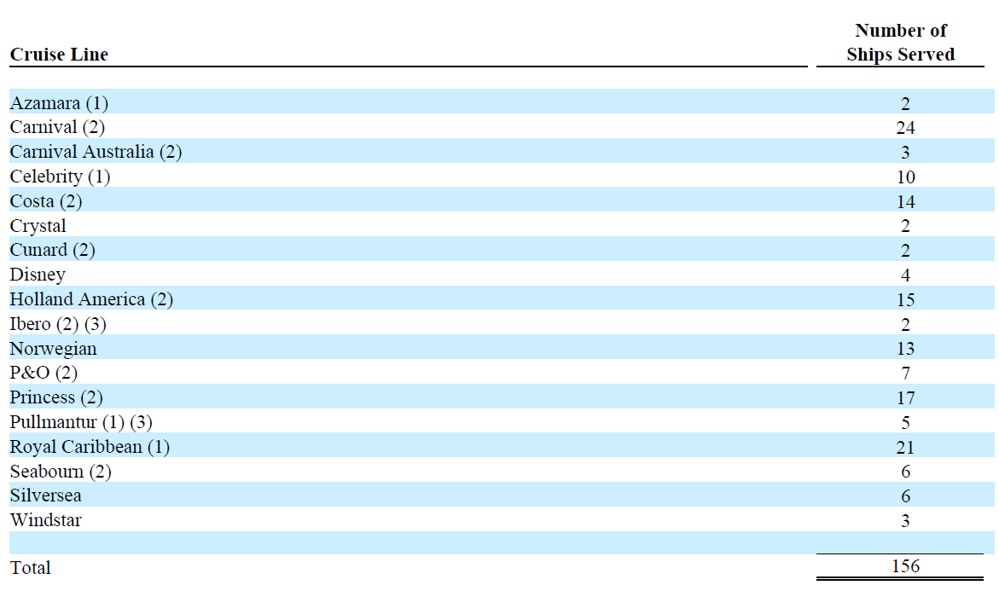
Each of Costa, Princess and Royal Caribbean is scheduled to introduce a new ship into service in 2014. We expect to perform services on all of these ships, each of which is currently covered by our cruise line agreements.

Since November 1996, none of our cruise line agreements was terminated prior to its expiration date. Historically, almost all of our cruise line agreements that have expired have been renewed beyond their specified expiration dates, although our agreement with Celebrity, which expired in December 2013, has not been renewed. The total number of ships we serve is affected from time to time by cruise lines removing from service older ships as new ships are introduced, or otherwise

Revenues from passengers of each of the following cruise companies accounted for more than ten percent of our total revenues in 2013, 2012 and 2011, respectively: Carnival (including Carnival, Carnival Australia, Costa, Cunard, Holland America, Ibero, P&O, Princess and Seabourn cruise lines): 24.4%, 25.7% and 29.9% and Royal Caribbean (including Royal Caribbean, Celebrity (we will cease serving Celebrity ships in the second quarter of 2014), Pullmantur and Azamara cruise lines): 13.9%, 14.8% and 16.7%. These companies, combined, accounted for 128 of the 156 ships served by us as of February 1, 2014. If we cease to serve one of these cruise companies, or a substantial number of ships operated by a cruise company, it could materially adversely affect our results of operations

Our cruise line agreements give us the exclusive right to offer our services and the right to sell products on board the ships we serve. COMPETITIVE ADVANTAGE Services and products sold to passengers are billed to them by the cruise lines. The cruise lines retain a specified percentage of our gross receipts from such sales before remitting the remainder to us. Under the cruise line agreements, we are required to pay for the meals and accommodations for our shipboard employees.

Most of the cruise line agreements cover all of the then-operating ships of a cruise line and certain of the agreements cover new ships introduced by the cruise line during the term of the agreement. In the case of other agreements, new arrangements must often be negotiated between us and a cruise line as new ships enter service. The agreements have specified terms ranging from one to six years, with an average remaining term per ship of approximately two years as of February 1, 2014 (excluding the Celebrity agreement, which expired in December 2013 and whose ships we are serving on an interim basis). As of February 1, 2014, cruise line agreements that expire within one year covered 33 of the 156 ships served by us. These 33 ships accounted for approximately 7.2% of our revenue in 2013. We typically are able to begin negotiations to renew agreements six to 12 months prior to their expiration dates.

The cruise line agreements provide for termination by the cruise lines with limited or no advance notice under certain circumstances, including, among other things, the withdrawal of a ship from the cruise trade, the sale or lease of a ship or our failure to achieve specified passenger service standards.

As of February 1, 2014, agreements for four ships provided for termination for any reason by the cruise line on 90 days' notice and we served seven ships without written agreements. We are obligated to make minimum payments to certain cruise lines regardless of the amount of revenues we receive from guests. As of December 31, 2013, these payments are required by cruise line agreements covering a total of 89 ships served by us. As of December 31, 2013, we had guaranteed total minimum payments to cruise lines (excluding payments based on minimum amounts per passenger per day of a cruise applicable to certain ships) of approximately: $94.8 million in 2014, $8.0 million in 2015, $8.0 million in 2016, $8.0 million in 2017, $8.0 million in 2018 and $8.0 million thereafter. These amounts could increase under new or renewed agreements. The amounts set forth for the years after 2014 are the amounts that are currently calculable. It is anticipated that the actual amounts for each of those years could be significantly higher than the amounts indicated. (1) Azamara, Celebrity and Pullmantur are owned by Royal Caribbean. We will cease serving the ships of Celebrity during the second quarter of 2014. (2) Carnival Corporation, the parent company of Carnival Cruise Lines, also owns Carnival Australia, Costa, Cunard, Holland America, Ibero, P&O, Princess and Seabourn. (3) As of February 1, 2014, we served these ships without a written agreement.

Hotel Spas – General

We offer spa services and products on land at hotels principally in the United States, the Caribbean, Asia and the Pacific.

As of February 1, 2014, we provided spa services at hotels in the following locations:

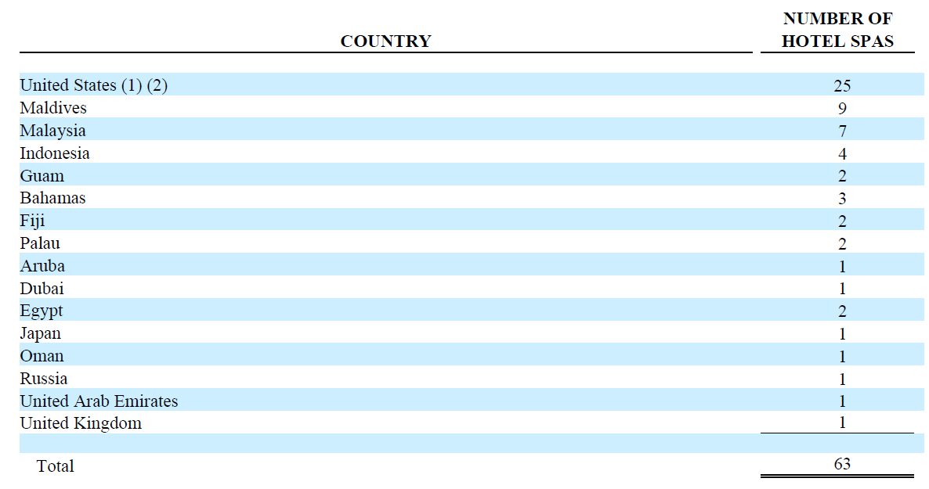

Land-Based Spa Agreements

We operate our land-based spas pursuant to agreements with the owners of the properties involved. Our hotel spas generally are required to pay rent based on a percentage of our revenues, with others having fixed rents. Similar to some of our cruise line agreements, certain of our land-based spa agreements also require that we make minimum rental payments irrespective of the amount of our revenues. As of December 31, 2013, we had guaranteed total minimum payments to owners of our land-based venues of approximately: $6.9 million in 2014, $5.8 million in 2015, $3.8 million in 2016, $2.3 million in 2017, $1.5 million in 2018 and $1.6 million in total thereafter. In connection with our spas at the Atlantis Resort and Casino, the One&Only Ocean Club, the Planet Hollywood Resort and Casino, the Hilton Hawaiian Village Beach Resort and Spa, the Loews Miami Beach Hotel, the Mohegan Sun Resort, the Wyndham Rio Mar, the Swan and Dolphin Hotel, the Grand Californian Hotel, the Tropicana Las Vegas Hotel and Casino and at certain other hotels, in order to obtain the agreements for these premises, we agreed to build out all or a portion of the spa facilities at our expense. The costs of these build-outs have ranged from under $500,000 to $15.6 million. We believe that in order to procure agreements for certain spas at hotels in the future, we may be required to fund the build-out, in whole or in part, of the spa facilities at those hotels. Those build-outs also likely will involve expenditures per facility comparable to, or in excess of, the expenditures we have spent to date on the build-out of hotel spa facilities. The terms of the agreements for our land-based spas generally range from five to 20 years (including the terms of renewals available at our option).

We operate 12 post-secondary schools providing education in massage therapy and, in some cases, beauty and skin care, and related areas at 32 campuses in a total of 14 states. We offer full-time programs as well as part-time programs for students who work or who otherwise desire to take classes outside of traditional education hours. Our schools' business began in August 1999, when we acquired a post-secondary school (comprised of four campuses) in Florida, offering degree and non-degree courses in massage and beauty and skin care. In April 2000, we acquired two post-secondary massage therapy schools with campuses located in Maryland, Pennsylvania and Virginia. In April 2006, we acquired the assets of the Utah College of Massage
Therapy, Inc. ("UCMT"), which operated a post-secondary massage therapy school with a total of seven campuses in Utah, Nevada, Arizona and Colorado and a small affiliate of UCMT that offers spa products, equipment and services to UCMT students and others. In August 2008, we acquired the assets of the Connecticut Center for Massage Therapy, Inc. ("CCMT"), which operated a post-secondary massage therapy school with a total of three campuses in Connecticut. In November 2011, we acquired the assets of Cortiva, which operated seven schools with a total of 12 campuses located in a total of seven states, including four where we had not operated schools previously. In 2011, 2012 and 2013, we opened new campuses in Dallas, Houston and Arlington, Texas, respectively.

As of February 1, 2014, there were a total of 4,663 students attending our schools.

We promote our services and products to cruise passengers and hotel guests through on-site demonstrations and seminars, video presentations shown on in-cabin/in-room television, ship newsletters, tours of our facilities, and promotional discounts on lower volume days, such as when a ship is in a destination port. We also distribute illustrated brochures describing our services and products to cruise passenger cabins and from public areas and guestrooms at the land-based venues where we operate. As part of our marketing efforts, we provide incentives to our employees to maximize sales of our services and products. Among other things, we instruct our employees in cross-promotion strategies intended to familiarize our customers with services and products of ours other than those included in their treatments and/or originally requested for purchase. We believe that such cross-promotional activities frequently result in our customers purchasing services and/or products in addition to those they initially contemplated buying. In addition, we engage in cross-promotional activities with other ship concessionaires. We also maintain a dedicated sales desk to facilitate pre-cruise spa booking and to disseminate spa information for charters and other groups of cruise passengers. Additionally, a number of ships we serve allow internet-based pre-cruise spa booking for passengers.

We market our hotel spas through various channels at the venues we serve. These channels include video messages, displays and advertisements in guestrooms and guest service directories, referrals from guest contact personnel, distribution of marketing materials through guest contact channels, advance sales to group meeting planners and attendees, signage, lobby displays, venue and hotel newsletters and hotel websites. In addition, employees cross-market other services and products offered by us to their guests. We also market our land-based spas through public relations activities aimed at television and other media coverage and through local radio advertising, as well as through direct marketing. We communicate promotions and promotional events through our www.timetospa.com, www.timetospa.co.uk, www.elemis.com, www.blissworld.com, www.blisslondon.co.uk and www.bodyworkmall.com websites. We also offer gift cards and other pre-use purchases at certain of our land-based spas.

We benefit from advertising by the cruise lines and land-based venues we serve, as cruise lines and land-based venues often feature their spa facilities and our services as part of their advertising campaigns.

We believe that our land-based spas have helped our product distribution as a result of the name recognition gained from those spas and the opportunities those spas have provided us to demonstrate the application and attributes of our products.

Loss of a Significant Cruise Line Customer Could Harm Us

As a result of the consolidation of the cruise industry, the number of independent cruise lines has decreased in recent years and this trend may continue. Also, historically, some smaller cruise lines have ceased operating for economic reasons and this may happen to other cruise lines in the future.

As a result of these factors, a small number of cruise companies, all of which currently are our customers, dominate the cruise industry. Revenues from passengers of each of the following cruise line companies accounted for more than ten percent of our total revenues in 2013, 2012 and 2011, respectively: Carnival (including Carnival, Carnival Australia, Costa, Cunard, Holland America, Ibero, P&O, Princess and Seabourn Cruise Lines): 24.4%, 25.7% and 29.9% and Royal Caribbean (including Royal Caribbean, Celebrity (we will cease serving Celebrity ships in the second quarter of 2014), Pullmantur and Azamara cruise lines): 13.9%, 14.8% and 16.7%. These companies also accounted for 128 of the 156 ships served by us as of February 1, 2014. If we cease to serve one of these cruise companies, or a substantial number of ships operated by a cruise company, it could materially adversely affect our results of operations and financial condition.

We are obligated to make minimum annual payments to certain cruise lines and owners of our land-based venues regardless of the amount of revenues we receive from customers. We may also be required to make such minimum annual payments under any future agreements into which we enter.

Accordingly, we could be obligated to pay more in minimum payments than the amount we collect from customers. As of December 31, 2013, these payments are required by cruise line agreements covering a total of 89 ships served by us and by 29 of the agreements for our land-based spas.

As of December 31, 2013, we guaranteed total minimum payments to cruise lines (excluding payments based on minimum amounts per passenger per day of a cruise applicable to certain ships served by us) of approximately $94.8 million in 2014, $8.0 million in 2015, $8.0 million in 2016, $8.0 million in 2017, $8.0 million in $2018 and $8.0 million thereafter. These amounts could increase under new or renewed agreements. Some of the minimum annual payments are calculated based upon minimum amounts per passenger per day of a cruise for passengers actually embarked on each cruise of the respectiveship. These payments could significantly increase the minimum payments set forth above. The amounts set forth for the years after 2014 are the amounts that are currently calculable. It is anticipated that the actual amounts for each of those years will be significantly higher than the amounts indicated. In general, we have experienced increases in required payments to cruise lines upon renewing, or entering into, new agreements with cruise lines.

As of December 31, 2013, we guaranteed total minimum payments to owners of our land-based venues of approximately: $6.9 million in 2014, $5.8 million in 2015, $3.8 million in 2016, $2.3 million in 2017, $1.5 million in 2018 and $1.6 million thereafter. These amounts could increase under new or renewed agreements.

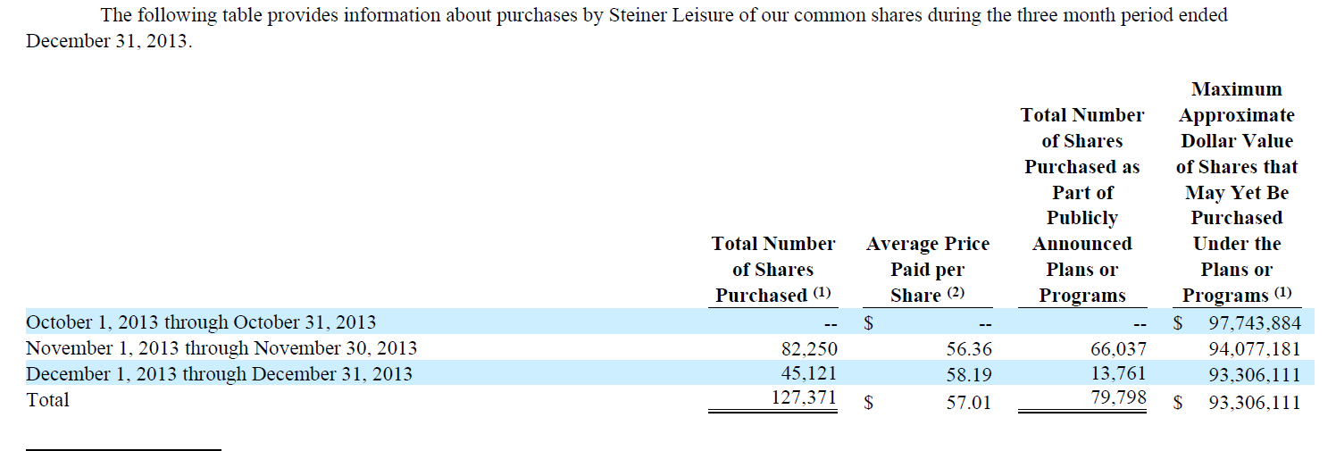
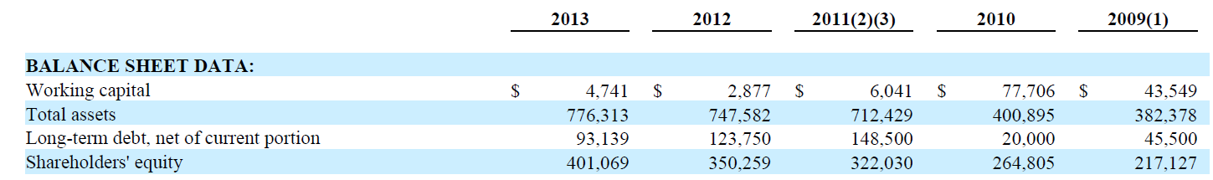
Improving balance sheet strengths and shareholders equity.

During 2013, we purchased 188,000 of our shares for a total of approximately $10.1 million under our previously adopted share repurchase plan.
Also, during 2013, 60,000 shares, with a value of approximately $3.5 million, were surrendered by our employees in connection with the vesting of restricted share units and used by us to satisfy payment of the federal income tax withholding obligations of those employees.

During 2012, we purchased 782,000 of our shares for a total of approximately $35.9 million under our previously adopted share repurchase plan. Also, during 2012, 80,000 shares, with a value of approximately $3.8 million, were surrendered by our employees in connection with the vesting of restricted share units and used by us to satisfy payment of the federal income tax withholding obligations of those employees. The surrendered shares in 2013 and 2012 were purchased outside our repurchase plan. All of these purchases were funded from our working capital. As of February 1, 2014, there remained approximately $93.3 million authorized for purchase under our share repurchase plan.

At December 31, 2013, our borrowing rate was 1.92%.

As of December 31, 2013, we had $93.1 million outstanding under our term loan and revolving facility. Our major market risk exposure is changing interest rates.

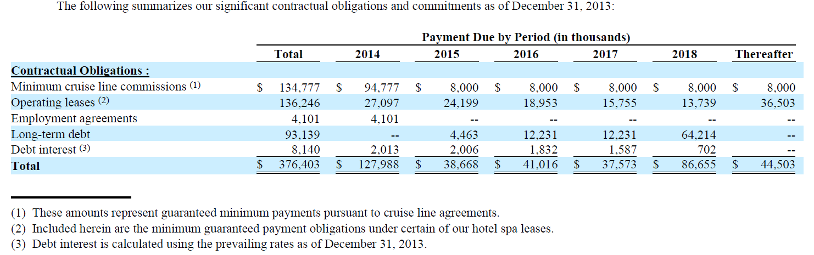
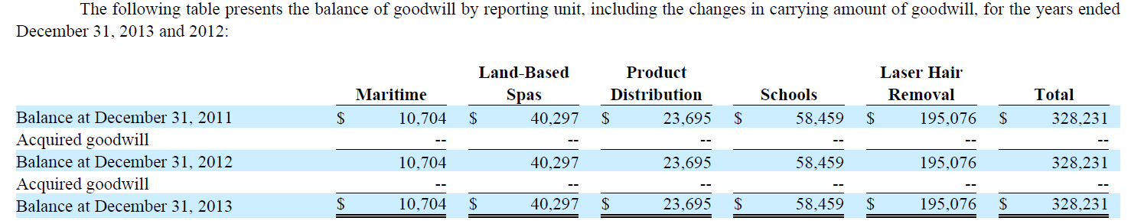
STNR has $101.3 million of NOLs.

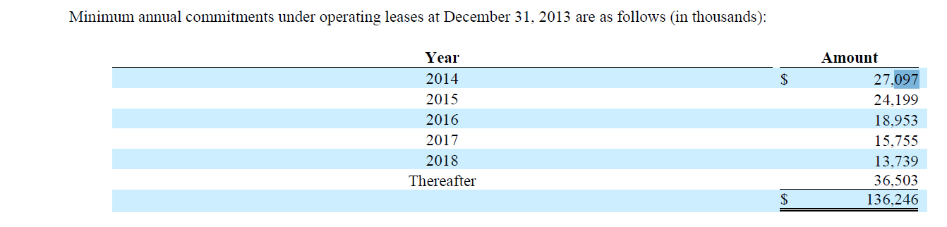
Beginning of 2014 TEV/EBIT and TEV/FCF

TEV = 723 + 93 + 189 op leases + 665 minimum cruise line agreements – 75 = 1595

- TEV/EBIT = 1595/60 =26.58
- EBIT/TEV = 3.8%
- TEV/FCF = 1595/65 = 24.54
- FCF/TEV = 4.1%

Unless otherwise mentioned notes below here are from most recent annual, quarterly, and proxy.

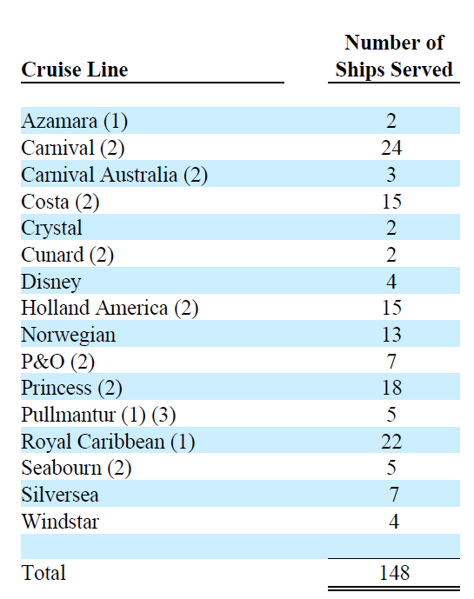
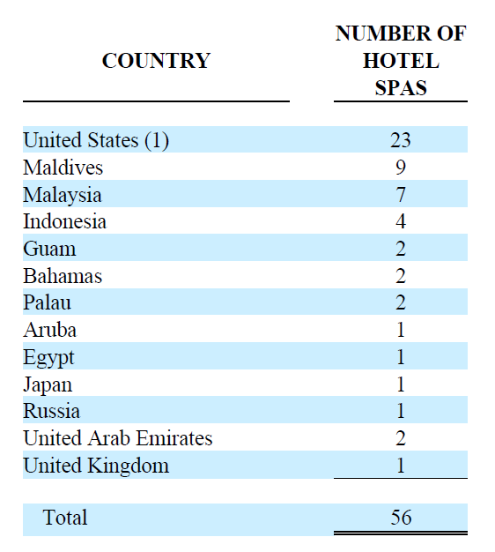
Revenues from passengers of each of the following cruise line companies accounted for more than ten percent of our total revenues in 2014, 2013 and 2012, respectively: Carnival (including Carnival, Carnival Australia, Costa, Cunard, Holland America, P&O, Princess and Seabourn Cruise Lines): 24.8%, 24.4% and 25.7% and Royal Caribbean (including Royal Caribbean, Pullmantur, Celebrity (until the second quarter of 2014, at which point we ceased serving Celebrity ships) and Azamara cruise lines): 10.6%, 13.9% and 14.8%. These companies also accounted for 118 of the 148 ships served by us as of February 2, 2015. If we cease to serve one of these cruise companies, or a substantial number of ships operated by a cruise company, it could materially adversely affect our results of operations and financial condition

During October, November and December 2014, 630,057 shares with a value of $26.0 million were purchased through the Company's then existing repurchase plan, which was approved on February 27, 2013 (the "Prior Repurchase Plan") and replaced the previously-existing plan. The Prior Repurchase Plan authorized the purchase of up to $100 million of our common shares in the open market or other transactions, of which $79,036,604 of our common shares were purchased to date. The shares purchased during November and December 2014 include repurchases of shares surrendered by our employees in connection with the vesting of restricted share units, which shares were used by us to satisfy payment of the federal income tax withholding obligations of those employees. SO NOT REALLY BUYING OUTSTANDING SHARES ON THE OPEN MARKET.

On February 18, 2015, the Company’s Board of Directors replaced the Prior Repurchase Plan with a new plan that authorizes the purchase of up to $100 million of our common shares in the open market or other transactions.

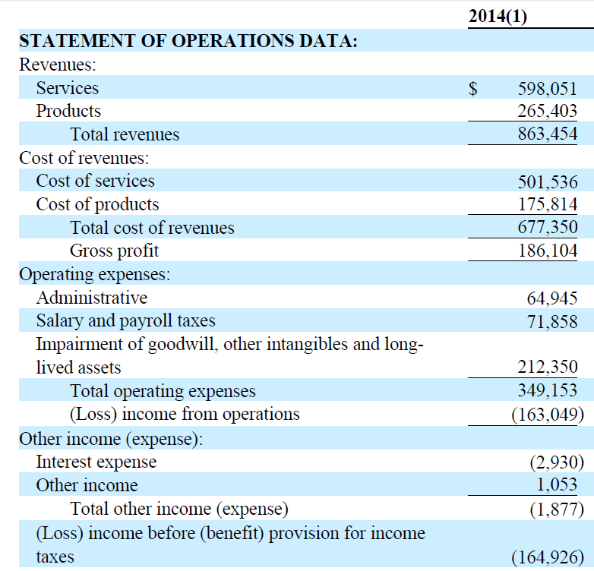
I wondered why STNR lost so much money in the TTM period. And why the book value of its shares was halved in one year. The above chart shows why.

Notice the Impairment of goodwill, other intangibles, and long lived assets above to the tune of $212 million. Or $16.30 a share. This is where the value was lost.

Now below in the notes we need to figure out why this happened.

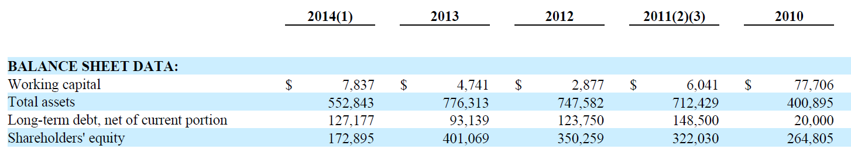
Also notice in the above chart also from the most recent 10K the huge loss off asset value and shareholder equity value. This is what writing down “assets” does to shareholder value.

As of February 2, 2015, we provided our spa services on 148 ships and at a total of 56 hotel spas located in the United States, the Caribbean, Asia, the Pacific and other locations, and at our day spas in New York City (two spas), Coral Gables and London (two spas).

Beginning in the latter part of 2013 and continuing through 2014, there was a decline in the number of Ideal Image customer leads generated through our marketing efforts. We are taking steps to address this decline through changes in our marketing strategy and tactics. However, we cannot assure you that these efforts will be successful in addressing this matter, and, if they are not successful, our results of operations and financial condition would be adversely affected.

During the fourth quarter of 2014, the Ideal Image reporting unit's overall financial performance continued to decline, including having negative cash flows and a decline in actual revenues as compared to what we had planned. This recent performance has also adversely affected our forecasts of the returns for this reporting unit. As a result of the decline in recent and forecasted performance of this reporting unit, during the fourth quarter of 2014, we reduced the carrying values of certain related assets by $177 million, and have recorded a corresponding tax benefit of $4.2 million. See Note (2) Summary of Significant Accounting Policies for more information regarding this charge

As of December 31, 2013, our agreement with Celebrity expired and we were notified that it would not be renewed. The impact of the loss of the Celebrity agreement on earnings per share for the year ended December 31, 2014 was $0.24 per share.

PART OF THE IMPAIRMENT EXPLANATION BELOW
In the fourth quarter of 2014, an impairment of $14.6 million was recorded for certain long-lived assets, primarily leasehold improvements, related to Ideal Image centers which are expected to generate negative cash flows through their respective lease end dates, as a result of which, their carrying values were not recoverable.

As of January 1, 2014, we reviewed the carrying value of goodwill and other indefinite lived intangible assets of each of our reporting units and concluded for each reporting unit that the implied fair value of goodwill exceeded its carrying value.

THE ABOVE IS CONFUSING BECAUSE THEY HAD TO IMPAIR AND WRITE OFF THE VALUE OF SOME ASSETS ALREADY MENTIONED SEVERAL TIMES ABOVE. SO WHY WOULDN’T THEY HAVE TO IMPAIR SOME OF THE VALUE OF GOODWILL STATED WHEN THEY ACQUIRED IDEAL IMAGE? NEED TO CHECK IN THE NOTES AGAIN FOR AN ANSWER.

During the fourth quarter of 2014, we concluded that, as a result of current conditions and circumstances, and in connection with Accounting Standards Codification No. 350, Intangibles – Goodwill and Other, and No. 360, Property, Plant, and Equipment, the Ideal Image and Schools reporting units were at risk of their respective carrying values exceeding fair values as of December 31, 2014.

As a result of the interim impairment test completed as of December 31, 2014, we recorded goodwill impairment charges of $151.7 million in our Ideal Image reporting unit and $27.7 million in our Schools reporting unit.

In addition, in conjunction with the second step of the goodwill impairment test, fair values are assigned to all assets and liabilities for each reporting unit, including all other intangible assets, as if the reporting unit had been acquired in a business combination. As a result, there was an impairment charge to the Ideal Image trade name of $11.0 million and a $7.2 million charge to the Title IV rights for the Schools.

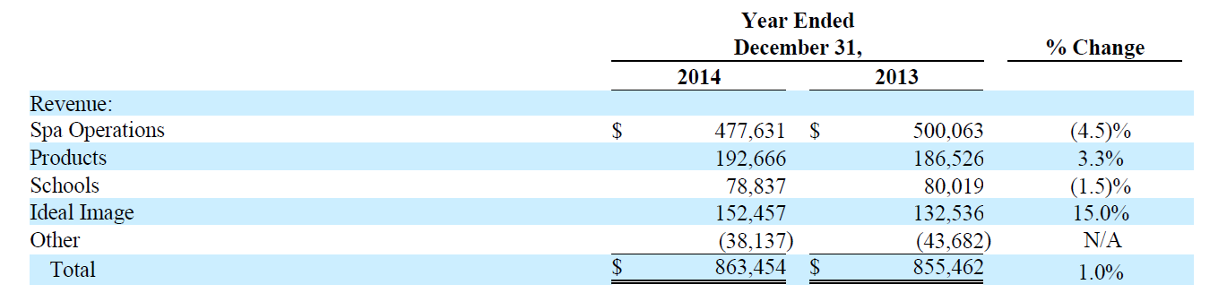
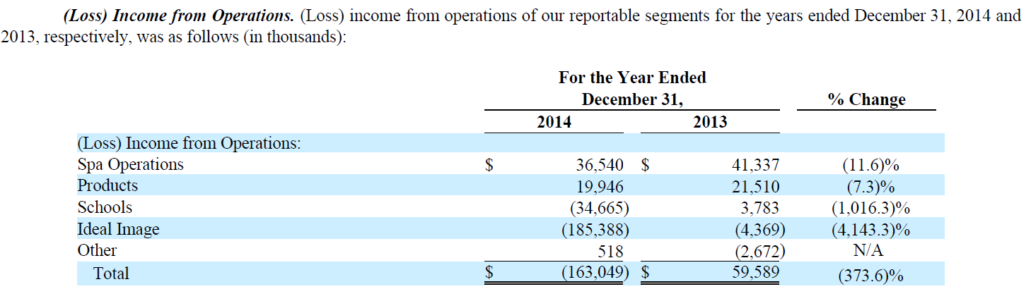
OUCH

During 2014, we recorded impairment charges of $35.0 million in our Schools segment.

Cost of Services . Cost of services increased $31.6 million to $495.2 million in 2013 from $463.6 million in 2012. Cost of services as a percentage of services revenue increased to 83.4% in 2013 from 81.3% in 2012. This increase was primarily attributable to the opening of 29 new Centers during 2013.

Cost of Products . Cost of products increased $6.0 million to $174.0 million in 2013 from $168.0 million in 2012. Cost of products as a percentage of products revenue decreased to 66.5% in 2013 from 69.7% in 2012. This decrease was primarily attributable to more higher margin products being sold in 2013 compared to 2012.

Operating Expenses . Operating expenses increased $12.5 million to $126.6 million in 2013 from $114.1 million in 2012. Operating expenses as a percentage of revenues was increased to 14.8% in 2013 from 14.1% in 2012. These increases were primarily attributable to the costs incurred to open new Centers in the second half of 2012 and to open 29 new Centers in 2013 and the reversal in 2012 of accruals related to performance-based compensation that was not earned.

OUCH AGAIN… NOT ONLY DID THE COMPANY HAVE TO IMPAIR/WRITE DOWN MORE THAN $200 MILLION OF “ASSETS” BUT COSTS AND EXPENSES ARE STILL RISING. HUGE DETERIORATION IN THE BUSINESS ECONOMICS IN THE LAST YEAR.

During 2014, we purchased 1,841,000 of our shares for a total of approximately $75.4 million under our previously adopted share repurchase plan. Also, during 2014, 69,000 shares, with a value of approximately $3.0 million, were surrendered by our employees in connection with the vesting of restricted share units and used by us to satisfy payment of the federal income tax withholding obligations of those employees.

During 2013, we purchased 188,000 of our shares for a total of approximately $10.1 million under our previously adopted share repurchase plan. Also, during 2013, 60,000 shares, with a value of approximately $3.5 million, were surrendered by our employees in connection with the vesting of restricted share units and used by us to satisfy payment of the federal income tax withholding obligations of those employees. The surrendered shares in 2014 and 2013 were purchased outside our repurchase plan.

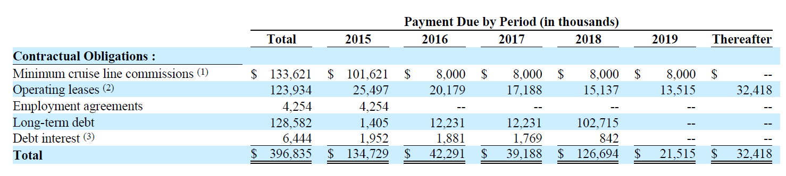

FOLLOWING NUMBERS ARE FROM 2014 ON THE LEFT AND 2013 ON THE RIGHT.

SO STNR DID WRITE DOWN GOODWILL BY ~$179 MILLION IN THE LAST YEAR.

As a result of the interim impairment test completed as of December 31, 2014 we recorded goodwill impairment charges of $151.7 million in our Ideal Image reporting unit and $27.7 million in our Schools reporting unit.

OUCH AGAIN…

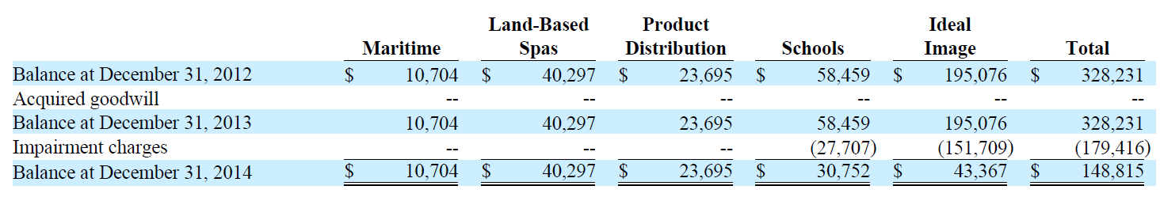

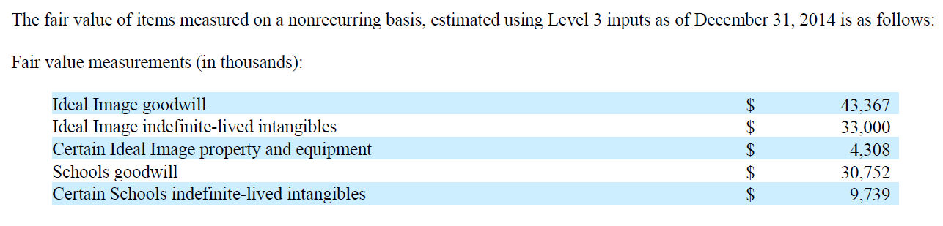

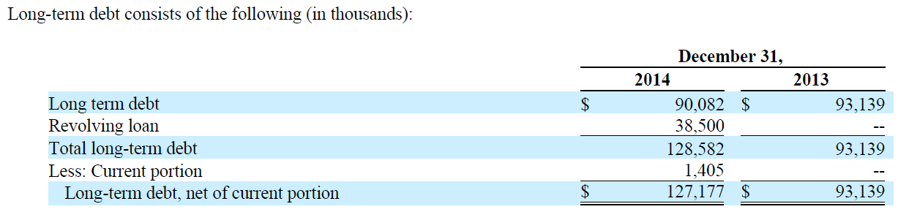
Our U.S. subsidiaries have available net federal operating loss carry forwards ("NOLs") of approximately $107.7 million, which are available through 2033 to offset future taxable income.

